PENETRATION TESTING REPORT
FOOTPRINTING & NETWORK SCANNING PHASES
W2-PM-FINAL | CYBERSECURITY | NETWORKWALKS
Pentester Name (Cybersecurity Professional) | Emmanuel Ufuah
Program/Batch | B082-Networkwalks
Date | 17 September 2026
Modules completed | W2-PM1 (Multiple Kali Tools)  W2-PM5 (Zenmap Scanning)
Client/Target | 1. Networkwalks (secured written permission already)  2. My own local LAN Network
Permission secured from client? | Yes
Phases covered | Phase 1: Reconnaissance & Footprinting  Phase 2: Scanning & Network Discovery  Phase 3-5: In Progress

1. Liability Disclaimer
I have performed these activities only on the systems & devices where I had secured written permission or the devices/systems that I own myself. All these materials are for education and research purpose only. Do not use anything from here to break the law. The instructor, the authors and Networkwalks are not responsible for what you do with this knowledge. Every action you take is your own responsibility. Misuse can lead to criminal charges, heavy fines, loss of your job and a permanent record. In most countries unauthorised access is a crime even when nothing is damaged.

2. Introduction
This report covers footprinting the networkwalks.com domain using multiple Kali Linux tools (W2-PM1) and scanning my own local network with Zenmap (W2-PM5). One module covers the footprinting phase and the other covers the scanning phase, so together they show how an attacker moves from gathering public information to mapping live hosts on a network. It is the Week 2 part of my ongoing internship program at Networkwalks.
All commands were run in Kali Linux, including both the footprinting tools and the Zenmap network scan. Every step below includes the exact command used, the result I observed, a screenshot as evidence, and a short note on why the finding matters from an attacker's point of view.

3. Tools Used
The table below lists each tool used in this report and its purpose.
Tool | Purpose
Kali Linux (VirtualBox VM) | Operating system environment used for all reconnaissance and scanning activities
WHOIS | Find domain registration details (registrar, dates, name servers)
WhatWeb | Fingerprint web technologies (server, CMS, plugins, IP)
Nslookup | Resolve the domain name to its IP address using DNS
curl -i | Read the HTTP response headers of the website
Wafw00f | Detect whether a Web Application Firewall protects the site
theHarvester | OSINT enumeration of subdomains, ASNs, IPs and emails (used in place of DNSRecon, which was not installed on this build)
Zenmap (Nmap GUI) | Scan the local subnet to find live hosts, IP addresses and MAC addresses

4. Activities Performed

4.1 Footprinting & Reconnaissance
I performed reconnaissance against the networkwalks.com domain using WHOIS, WhatWeb, Nslookup, Curl and Wafw00f, and used theHarvester in place of DNSRecon, which was not available on this Kali build. Each tool was used to collect a different type of information about the target.
First, I used WHOIS to obtain publicly available domain registration information. The domain is registered with GoDaddy.com, LLC, was created on 6 November 2019 and is set to expire on 6 November 2027. The registrant and technical contact details are masked behind Domains By Proxy, LLC, and the domain resolves through name servers NS6135/NS6136.HOSTGATOR.COM (with NS29/NS30.DOMAINCONTROL.COM also listed on the registrar's record). All four client-side domain locks (delete, renew, transfer, update prohibited) are enabled.
I then used WhatWeb to identify technologies used by the website. The results identified WordPress 7.1 and WP Download Manager 3.3.58, along with Apache as the web server, jQuery 3.7.1, Bootstrap 7.1, Google Tag Manager, and IP address 192.232.216.135.
Using Nslookup, I resolved the domain name to its IP address via Google's public DNS resolver (8.8.8.8). The result confirmed 192.232.216.135.
I used curl -i to inspect the HTTP response headers. This confirmed the Apache server and WordPress-specific behaviour (X-Redirect-By: WordPress - Really Simple Security, X-nginx-cache: WordPress), and exposed the WordPress REST API endpoint /wp-json/ along with a rel=shortlink link header.
Next, I used Wafw00f to determine whether a Web Application Firewall was protecting the website. The result identified ModSecurity (SpiderLabs).
I attempted to use DNSRecon to enumerate DNS records, but the command was not installed on this Kali build. As a substitute, I ran theHarvester (-b all) against the domain. It identified 3 ASNs (AS13335, AS31898, AS46606 — AS13335 is associated with Cloudflare), 3 IP addresses (192.232.216.135 and 172.67.198.228, the latter consistent with Cloudflare-fronted infrastructure), 1 contact email (info@networkwalks.com), and 20 hosts, including administrative and mail-related subdomains such as cpanel, webdisk, webmail, mail, ftp and several autodiscover variants.

4.2 Network Scanning with Zenmap
For the second activity, I used Zenmap (the Nmap GUI) inside my Kali VM to run a Ping Scan against my local /24 subnet using the command nmap -sn 10.0.0.0/24.
The scan covered 256 IP addresses in 7.09 seconds and identified 3 live hosts:
- 10.0.0.1 — host up, MAC address 52:55:0A:00:00:01 (vendor unknown), most likely the network gateway
- 10.0.0.2 — host up
- 10.0.0.3 — host up, my own device
After completing the scan, I opened the Topology section in Zenmap, which plotted the three discovered hosts around localhost. Since a ping scan does not include port or traceroute data, the connections were shown as "no traceroute information" dashed lines and each host was marked with fewer than 3 open ports on the legend's colour scale. I reviewed the Legend to confirm the icon meanings before saving the topology graphic.

5. Risk Analysis / Impact
Based on the information collected during the footprinting and network scanning activities, I identified the following potential risks.
# | Risk / Finding | Evidence / Observation | Potential Impact | Risk Level
1 | Web technology information exposed | WhatWeb identified WordPress 7.1 and WP Download Manager 3.3.58 | Attackers may use exposed technology/version information to identify software requiring further security review | Medium
2 | Server IP address identifiable | Nslookup resolved the domain to 192.232.216.135 | Provides information about the network location of the web service | Low
3 | HTTP technical information exposed | Curl returned HTTP response headers and exposed the /wp-json/ REST API endpoint | May assist technology fingerprinting and further enumeration | Low
4 | WAF technology identifiable | Wafw00f identified ModSecurity (SpiderLabs) | Reveals information about the web application's security architecture | Low
5 | Subdomain & infrastructure information exposed | theHarvester identified 20 hosts (cPanel, webmail, mail, ftp, autodiscover subdomains), 3 ASNs and a contact email | Subdomain and ASN information can help build a broader infrastructure profile and reveal administrative access points | Medium
6 | Multiple live hosts visible on local network | Zenmap ping scan identified 3 live hosts on the 10.0.0.0/24 subnet, including a MAC address on the gateway host | Unknown or unauthorized devices may potentially be present on a network | Medium

Risk level key: ● Critical ● Medium ● Low
The risks above are observations from the footprinting and scanning exercises, not confirmed vulnerabilities.
The practical exercises primarily involved information gathering and host discovery. No exploitation or vulnerability validation was performed as part of these two modules.
Therefore, the presence of information such as a software version, IP address, subdomain or MAC address does not by itself mean that the system is vulnerable. Further authorized security testing would be required to confirm any actual vulnerability.

6. Recommendations
Based on the observations from these activities, I recommend the following security improvements:
- Review publicly exposed technology information. Organizations should regularly review what information about their web technologies, CMS and plugins is publicly visible.
- Keep software updated. WordPress and its plugins (including WP Download Manager) should be regularly updated and reviewed against current security advisories.
- Review HTTP headers. HTTP response headers should be reviewed to determine whether unnecessary technical information, such as exposed API endpoints, is being disclosed.
- Audit exposed subdomains regularly. Administrative and mail-related subdomains (cPanel, webmail, webdisk, autodiscover, etc.) should be reviewed and restricted to authorized users where possible.
- Properly configure and monitor the WAF. Keep the WAF (ModSecurity) enabled and tuned, since it already blocks naive attacks.
- Perform regular internal network discovery. Organizations should periodically scan their own networks to identify active devices.
- Investigate unknown devices. Any unexpected device or MAC address discovered during network scanning should be investigated and verified.
- Maintain network documentation. Network topology and device information should be documented and updated regularly.
- Verify tool availability before an assessment. Confirm required tools (e.g. DNSRecon) are installed ahead of time, and keep a documented fallback tool for each enumeration step.
- Perform security testing with authorization. Reconnaissance and scanning should only be performed against systems and networks where appropriate authorization has been provided.

7. Conclusion
During Week 2 of my Cybersecurity & Ethical Hacking internship, I completed practical activities covering footprinting, reconnaissance and network scanning.
In the footprinting activity, I used WHOIS, WhatWeb, Nslookup, Curl and Wafw00f against the networkwalks.com domain, and substituted theHarvester for DNSRecon when the latter was unavailable. I learned how WHOIS can reveal registration and privacy-protection details, WhatWeb can identify web technologies and versions, Nslookup can resolve domain names, Curl can inspect HTTP headers and exposed endpoints, Wafw00f can identify a WAF, and theHarvester can enumerate subdomains, ASNs and contact emails even without a dedicated DNS enumeration tool.
In the network scanning activity, I used Zenmap to run a ping scan across my local /24 subnet, identify three live hosts, capture a MAC address for the likely gateway, and generate a network topology graphic.
The exercises showed me that information gathering is an important part of cybersecurity, and that when a preferred tool is missing, an equivalent tool can often achieve the same reconnaissance goal. Even before attempting to exploit a system, a security professional can learn a significant amount about an environment by carefully analyzing publicly available information and network responses.
I also learned that technical findings should be documented clearly. A good cybersecurity report should explain what was performed, what was discovered, what the observation means, what risk it may create, and what can be done to reduce that risk.
Finally, I learned that reconnaissance and scanning must always be performed within an authorized scope. These activities were completed as part of the assigned educational cybersecurity lab.

8. Evidences Collected
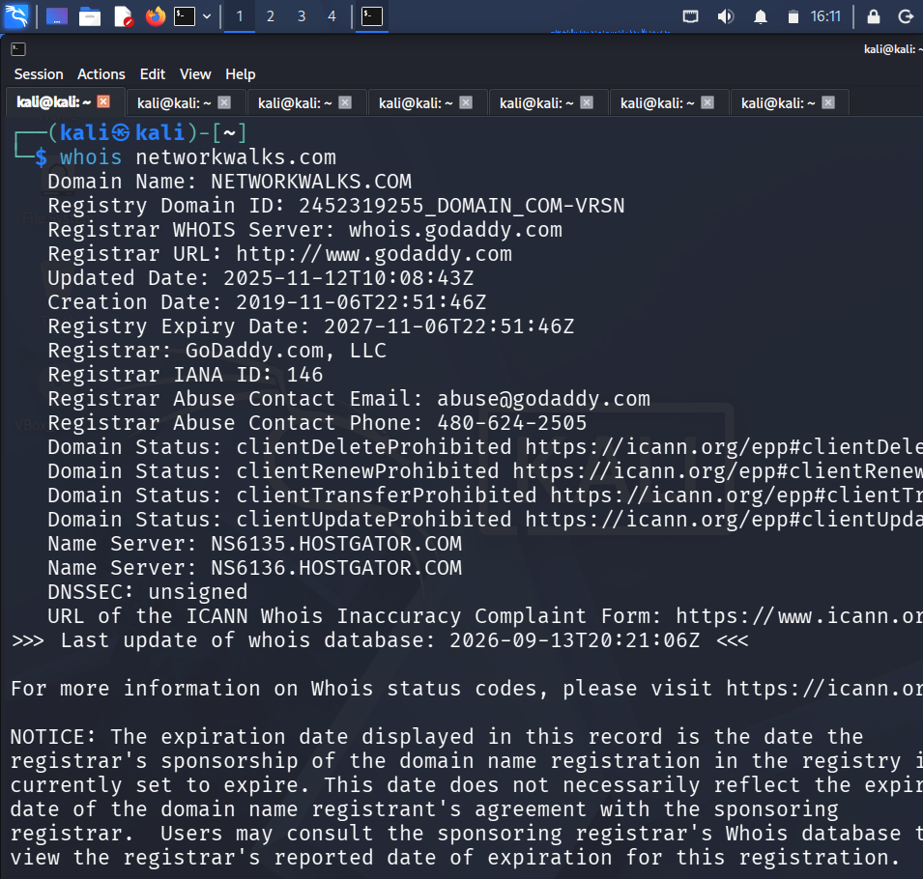
1. WHOIS lookup of networkwalks.com
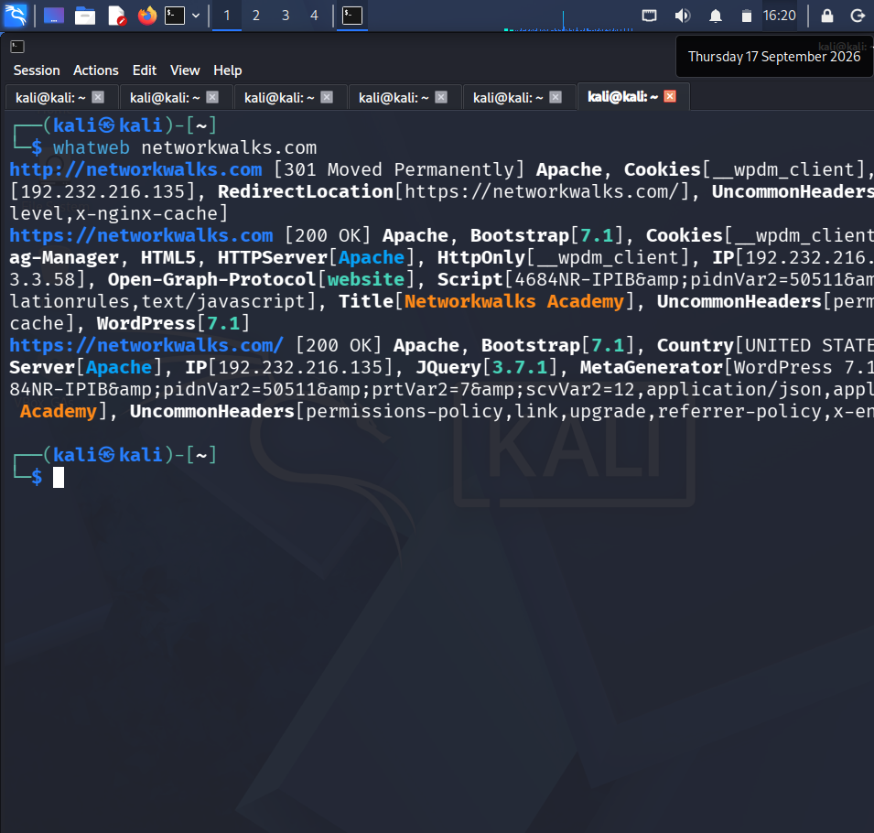
2. WhatWeb technology fingerprint of networkwalks.com
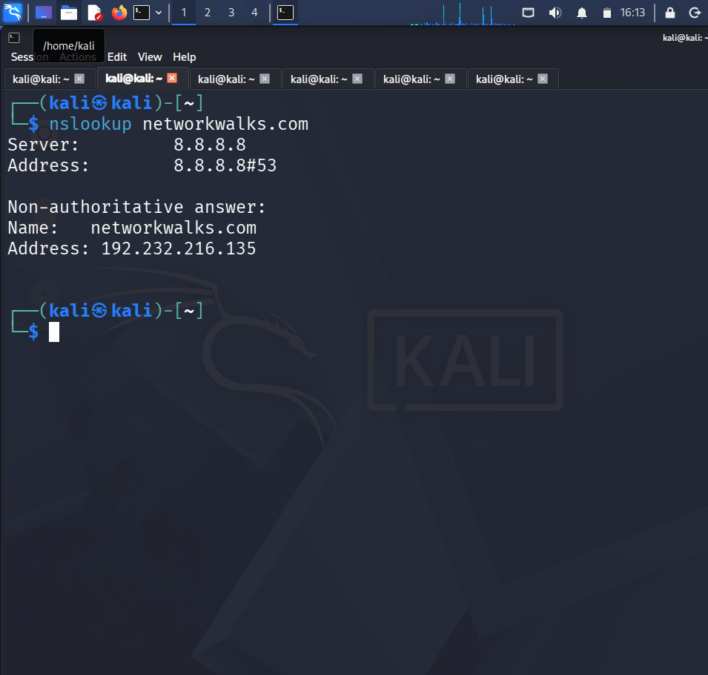
3. Nslookup resolving networkwalks.com
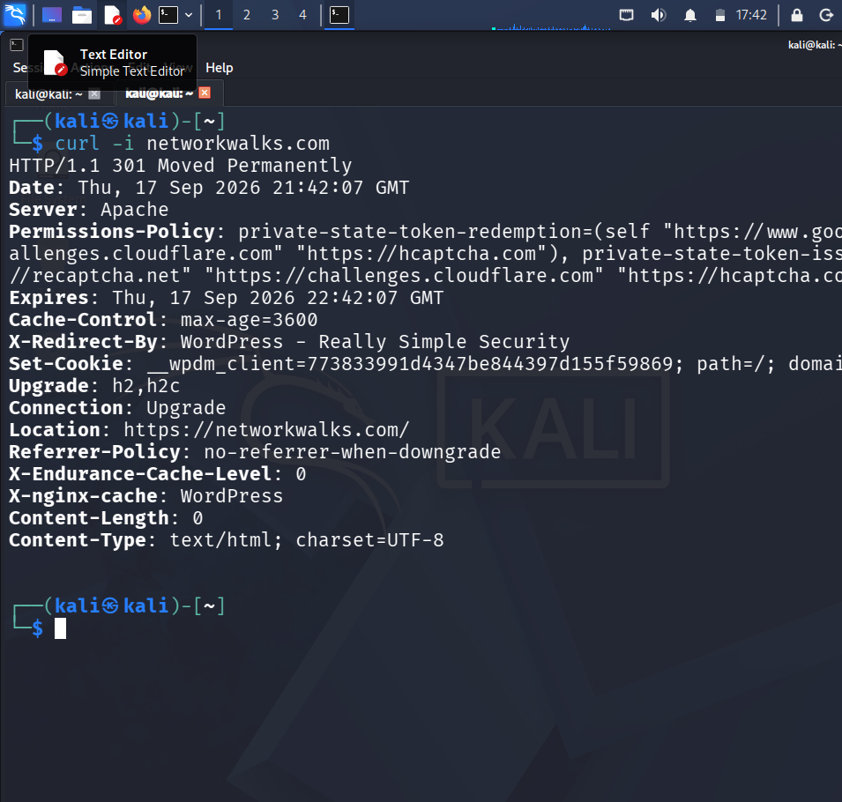
4. curl -i HTTP response headers
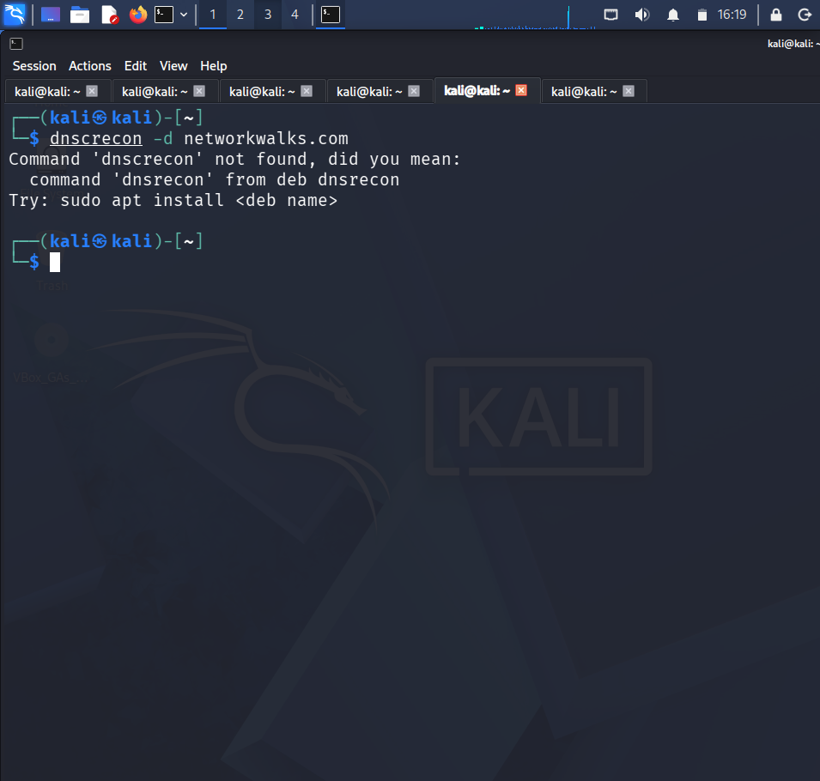
5. Wafw00f WAF detection result
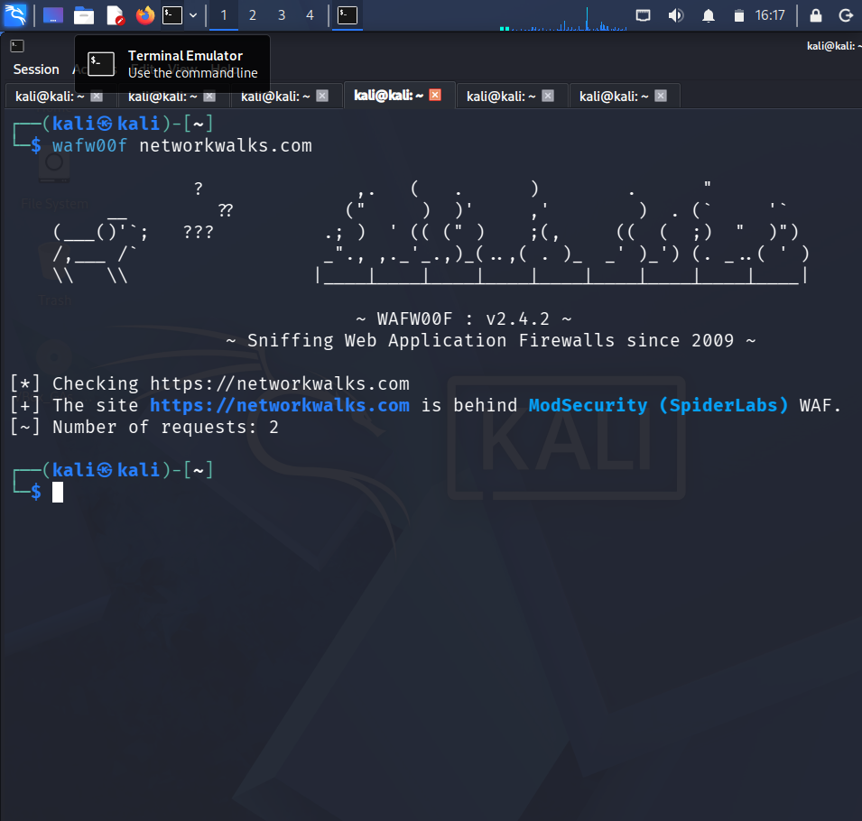
6. DNSRecon unavailable on this build (command not found)
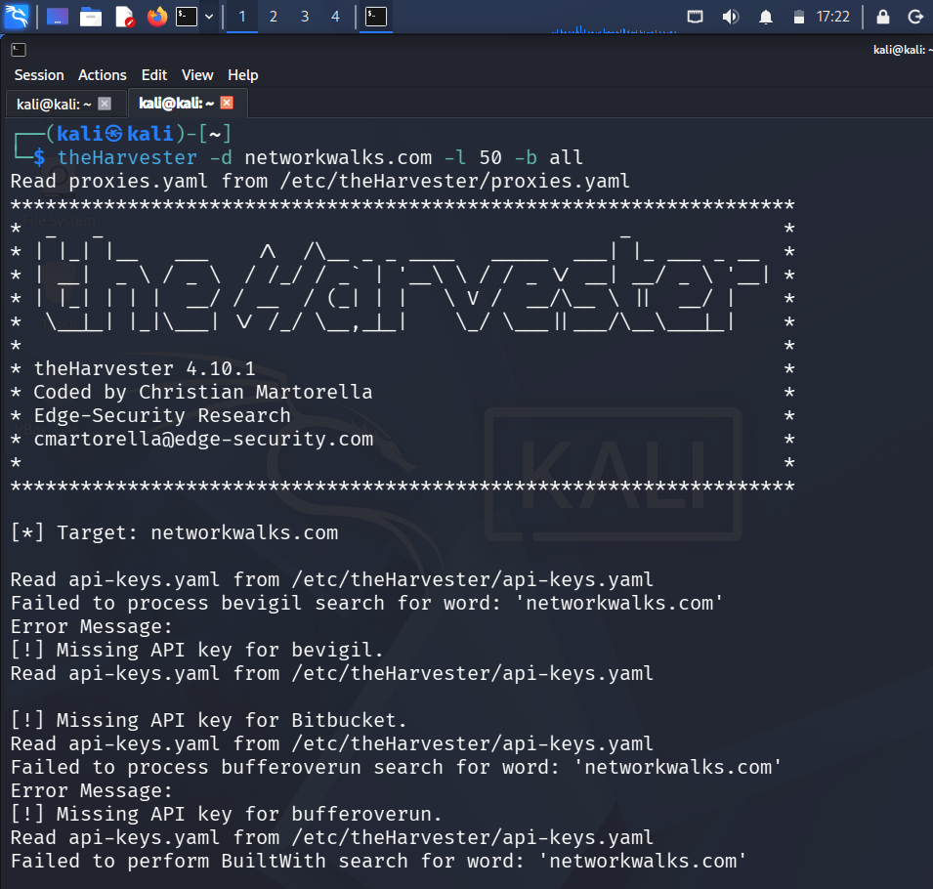
7. theHarvester OSINT enumeration results
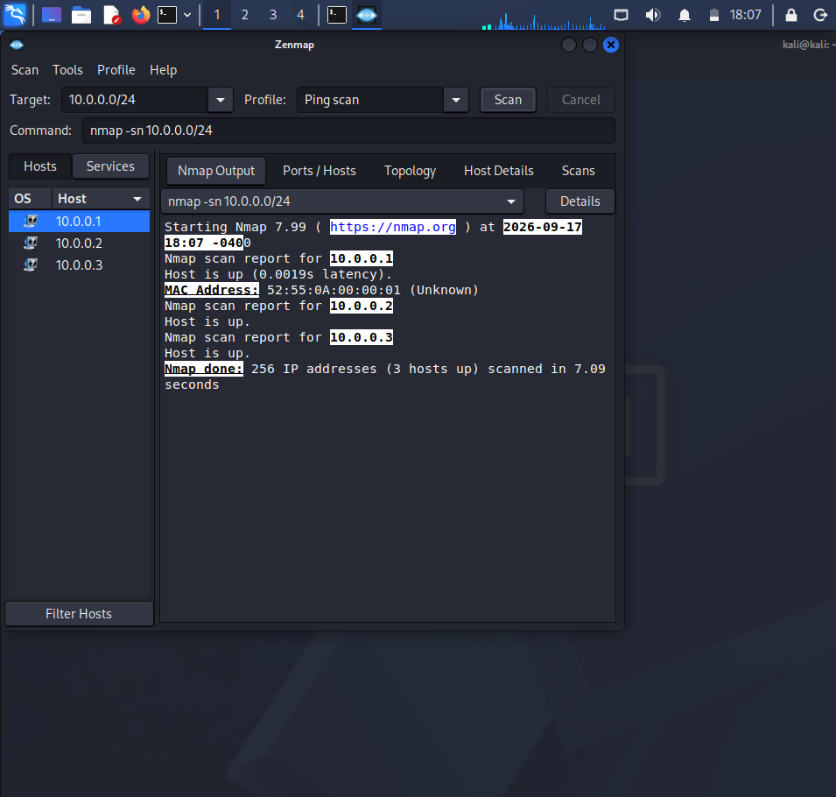
8. Zenmap/Nmap ping scan output (10.0.0.0/24)
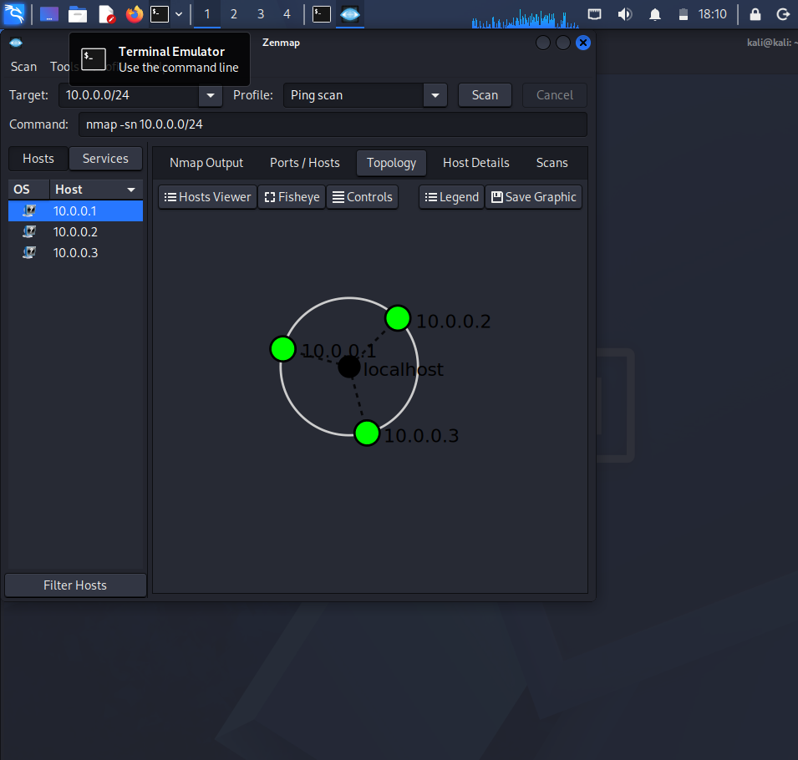
9. Zenmap network topology of discovered hosts

